# **Name: Abdurrahman Qureshi**

# **Roll No: 242466**

Practical No: 4

Date Of Performance: 29/07/2025

Aim: To understand and demonstrate the use of AWS Lambda Functions

1. To create a Lambda function which will log a message once you add an object to a specific bucket in S3. Use AWS Lambda blueprint.

 [Terminate the resources after performing the practical]

Ans 1:

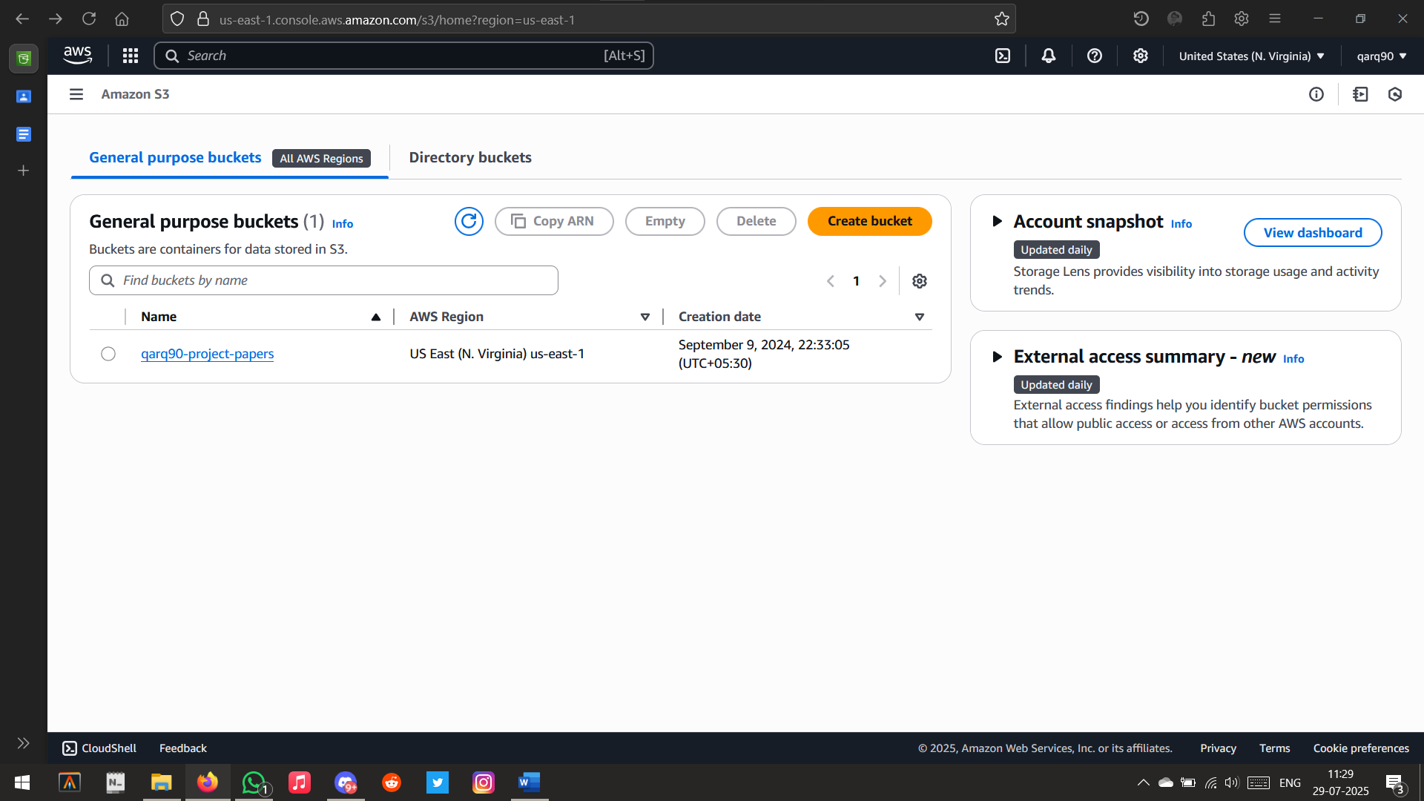

Creating a new bucket

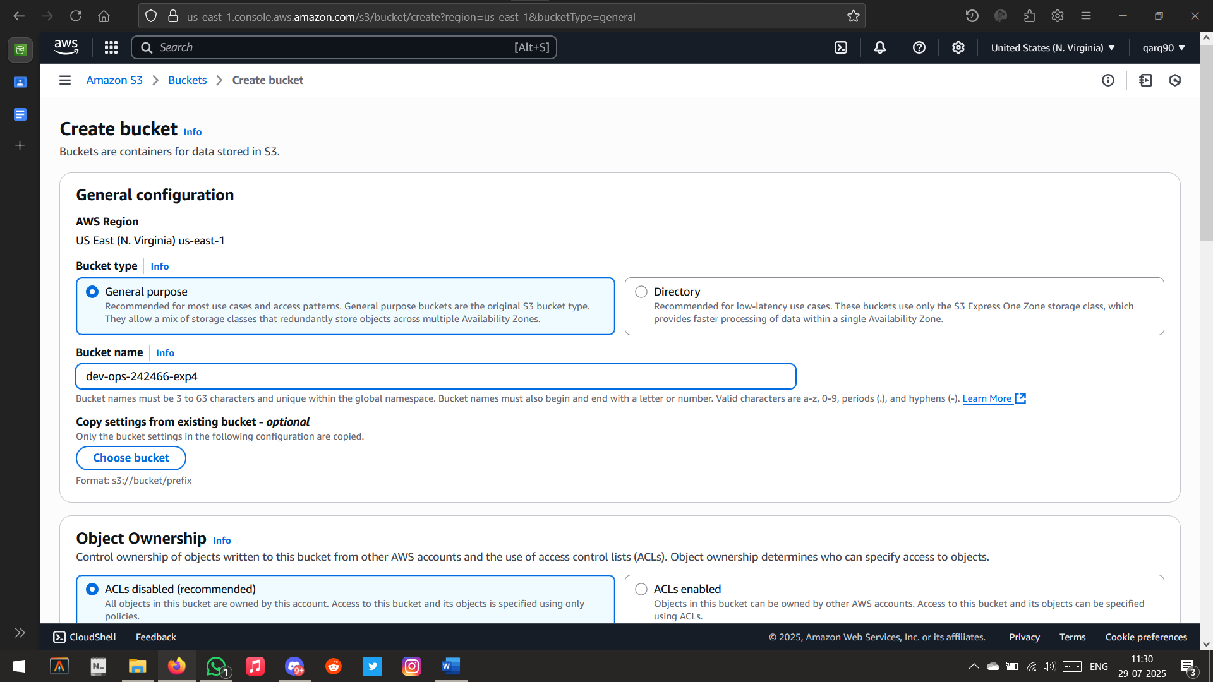

Setting bucket name

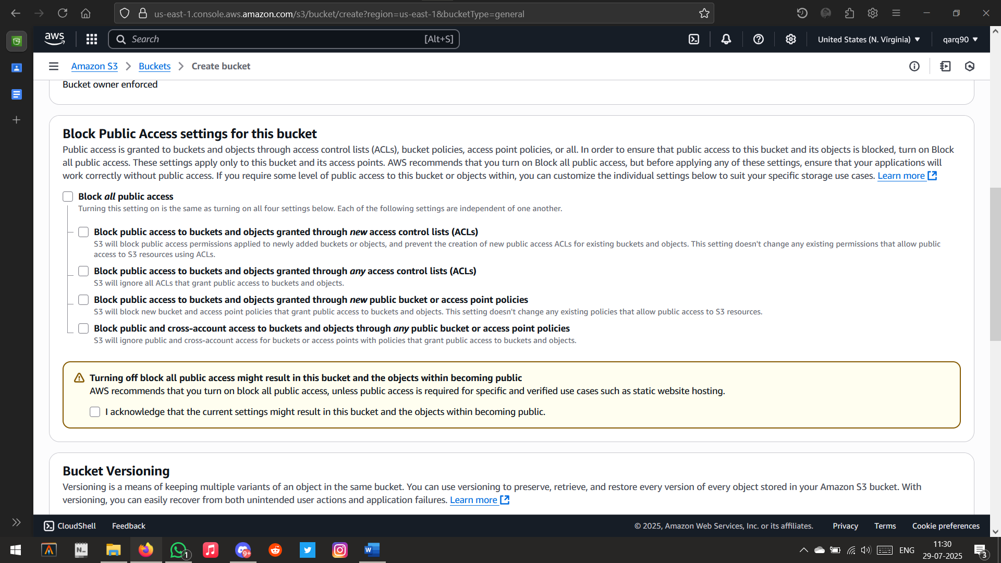

Allowing all public access

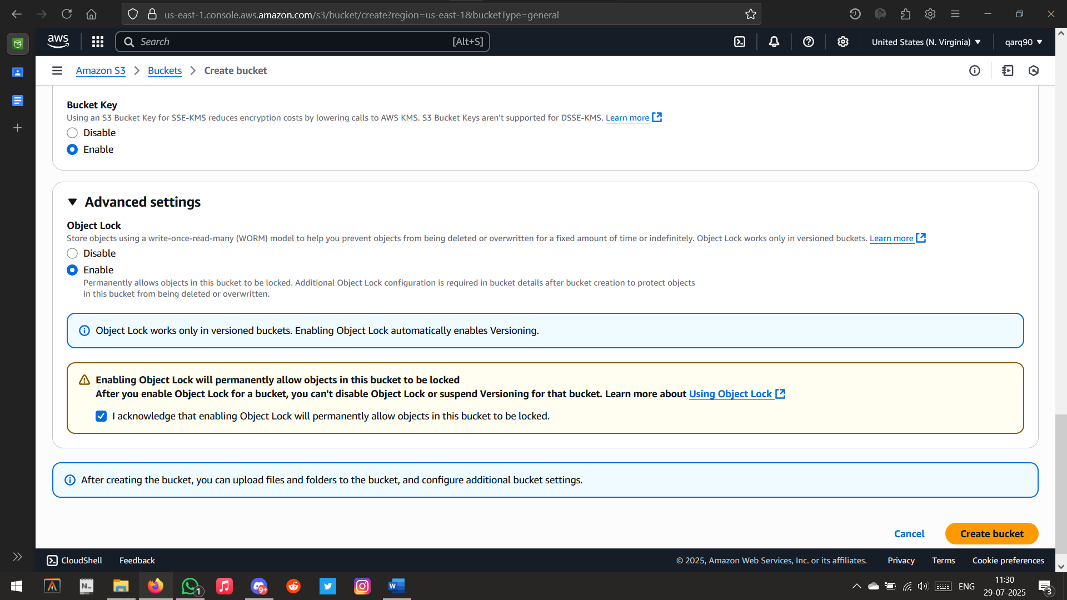

Configuring the Bucket settings

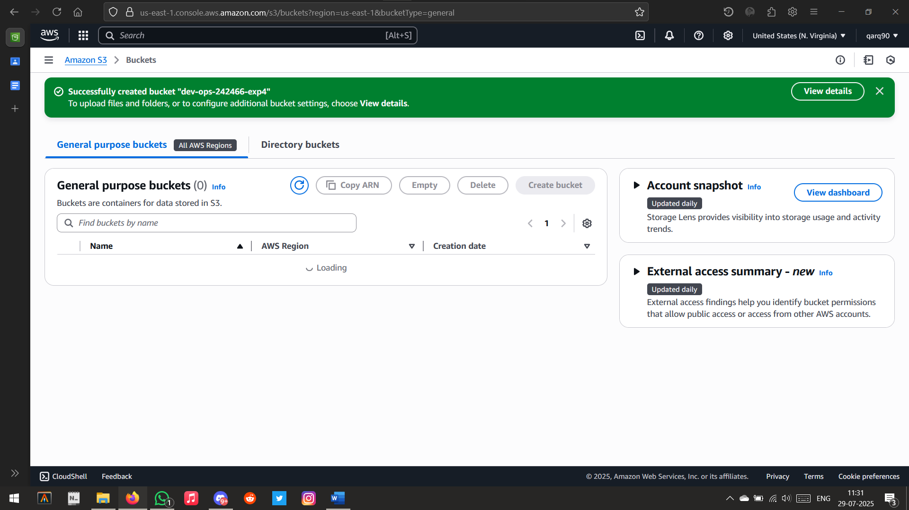

Bucket Created Successfully

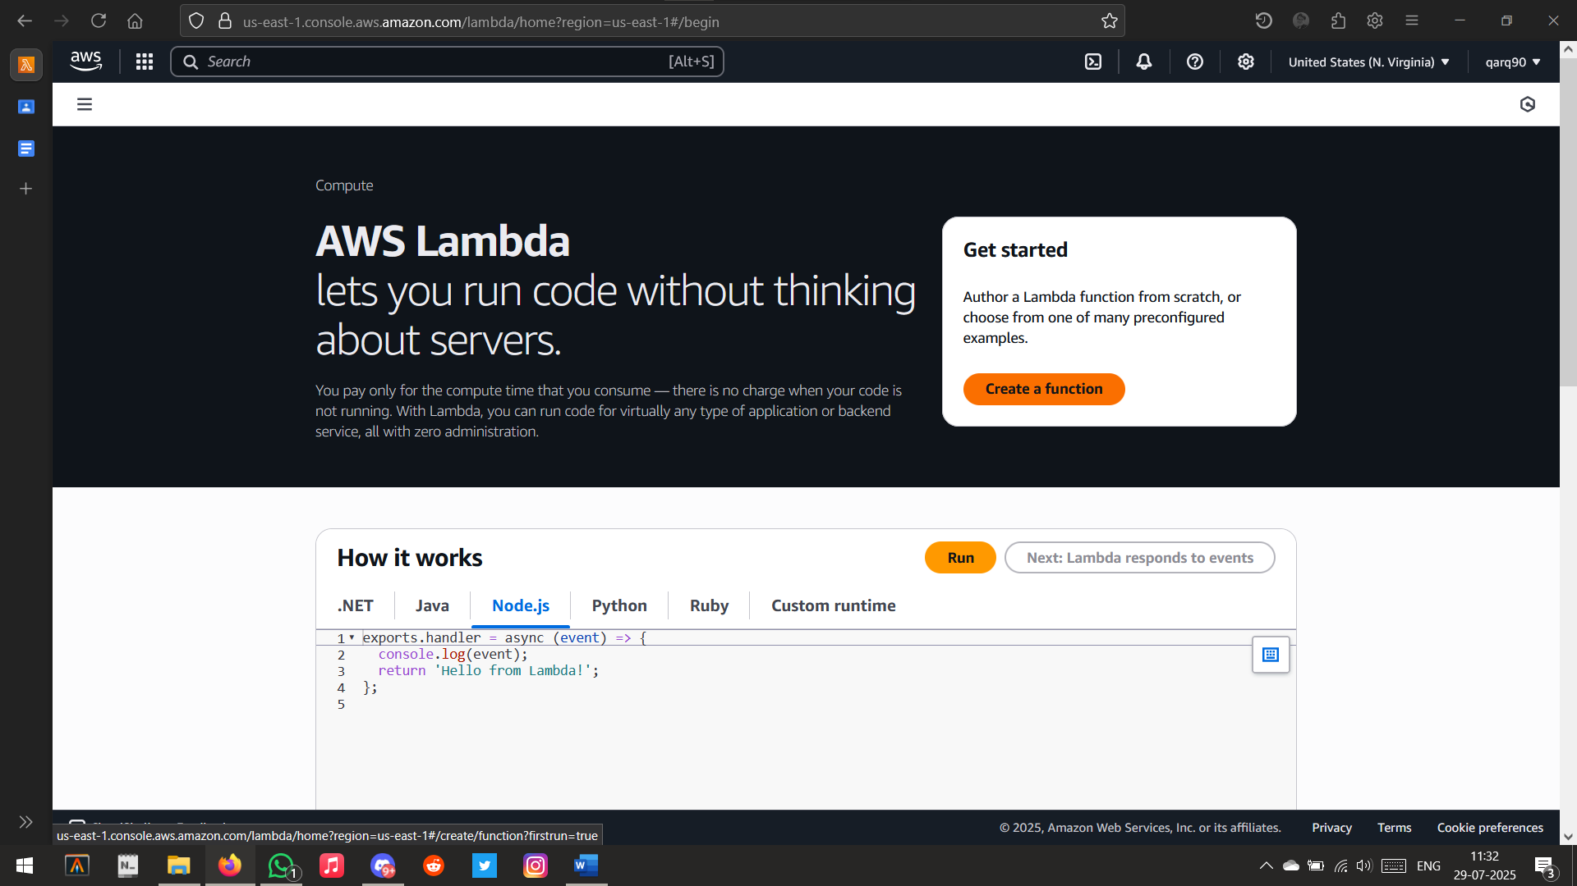

Creating a new Lambda Function

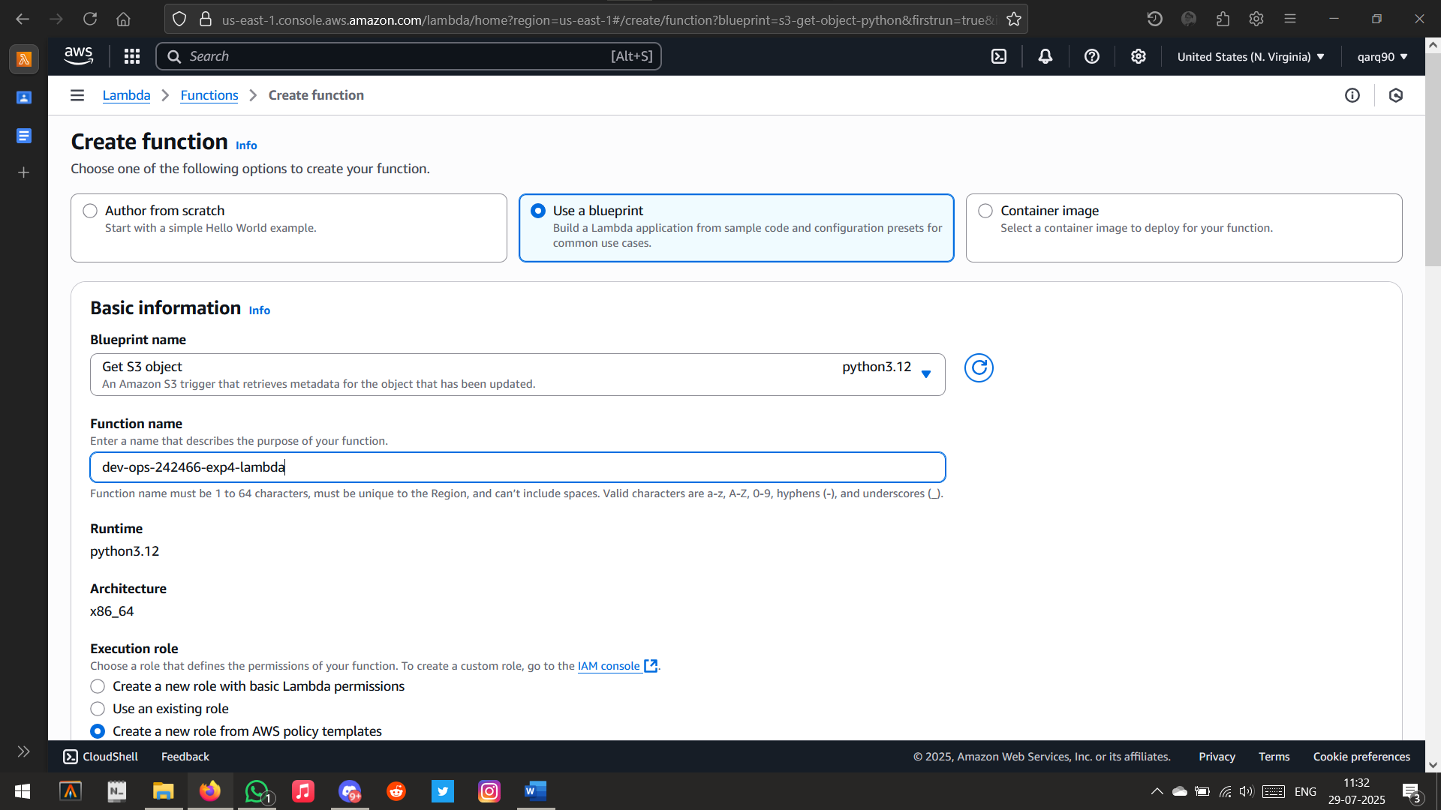

Setting new lambda function name

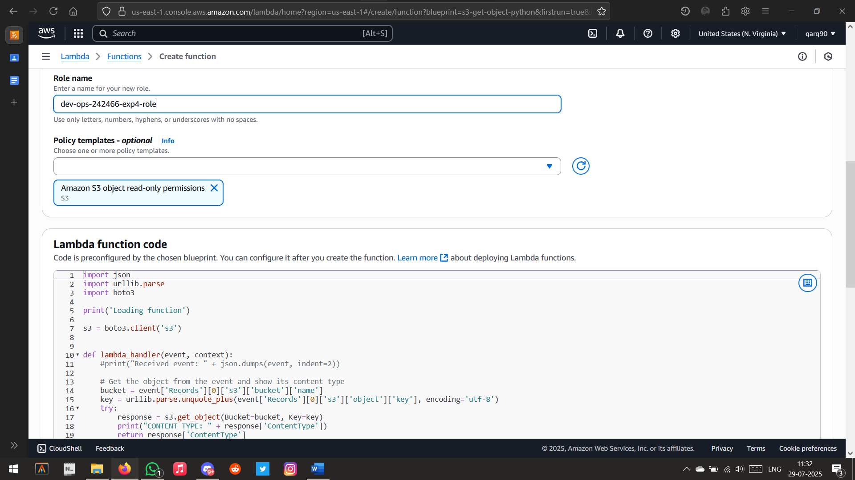

Choosing lambda bucket

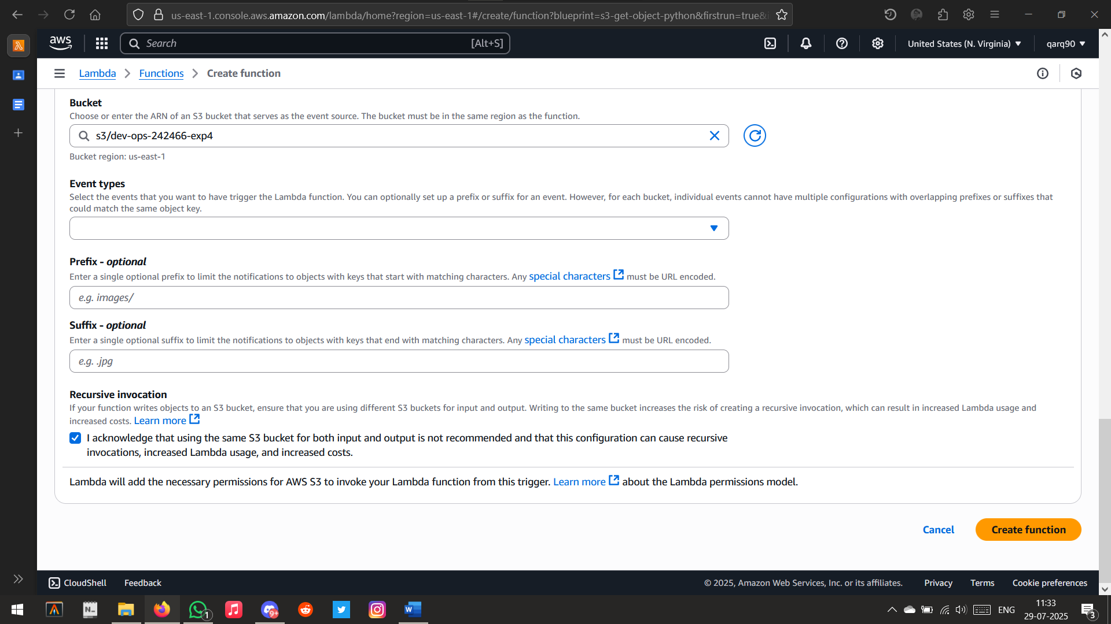

Acknowledging Invocation

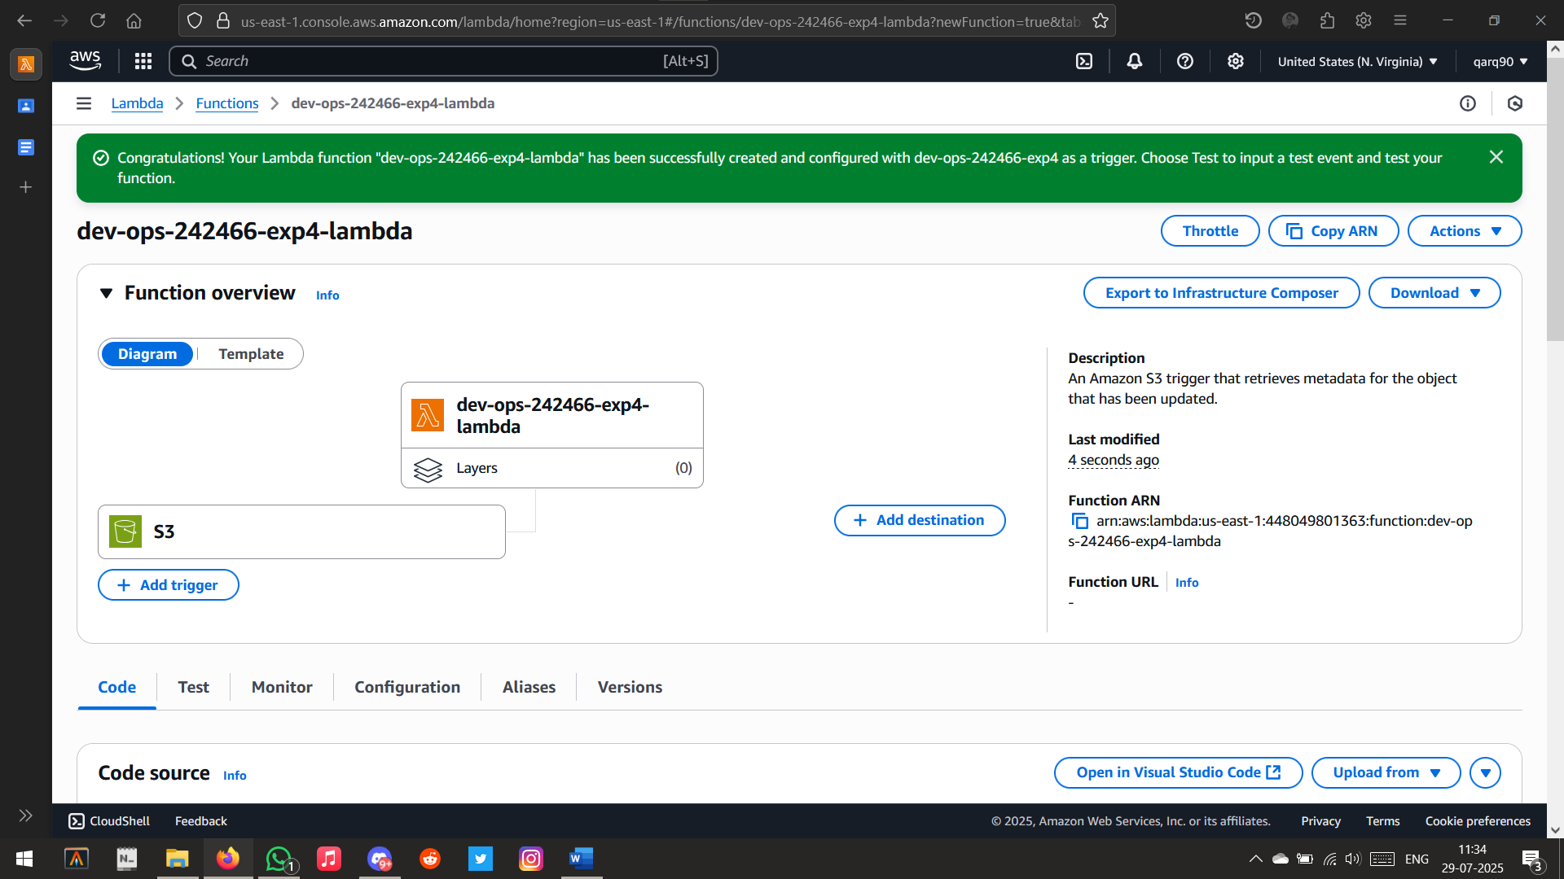

Lambda Function linked successfully

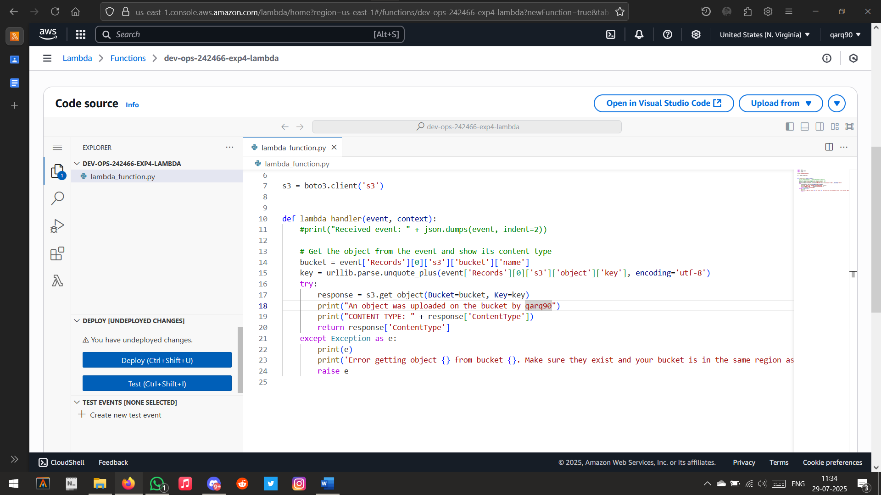

Editing the lambda function code

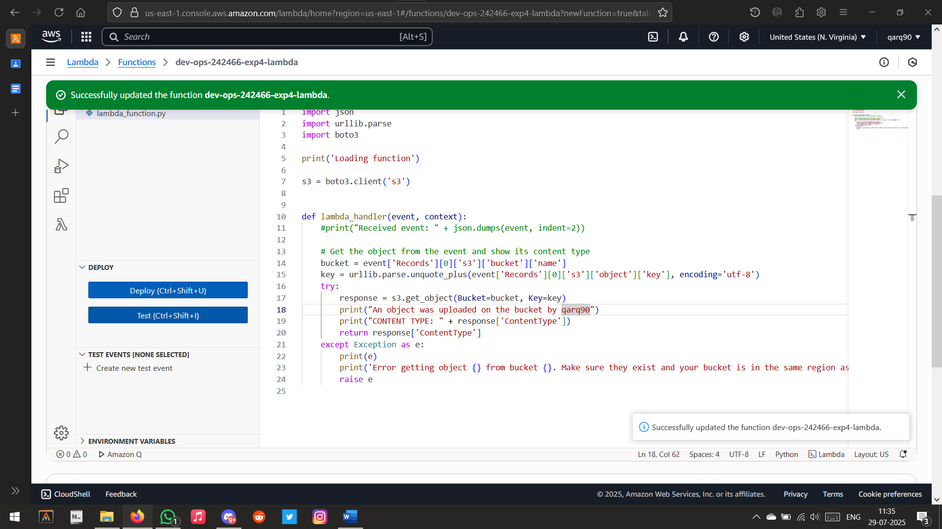

Successfully Updated the function

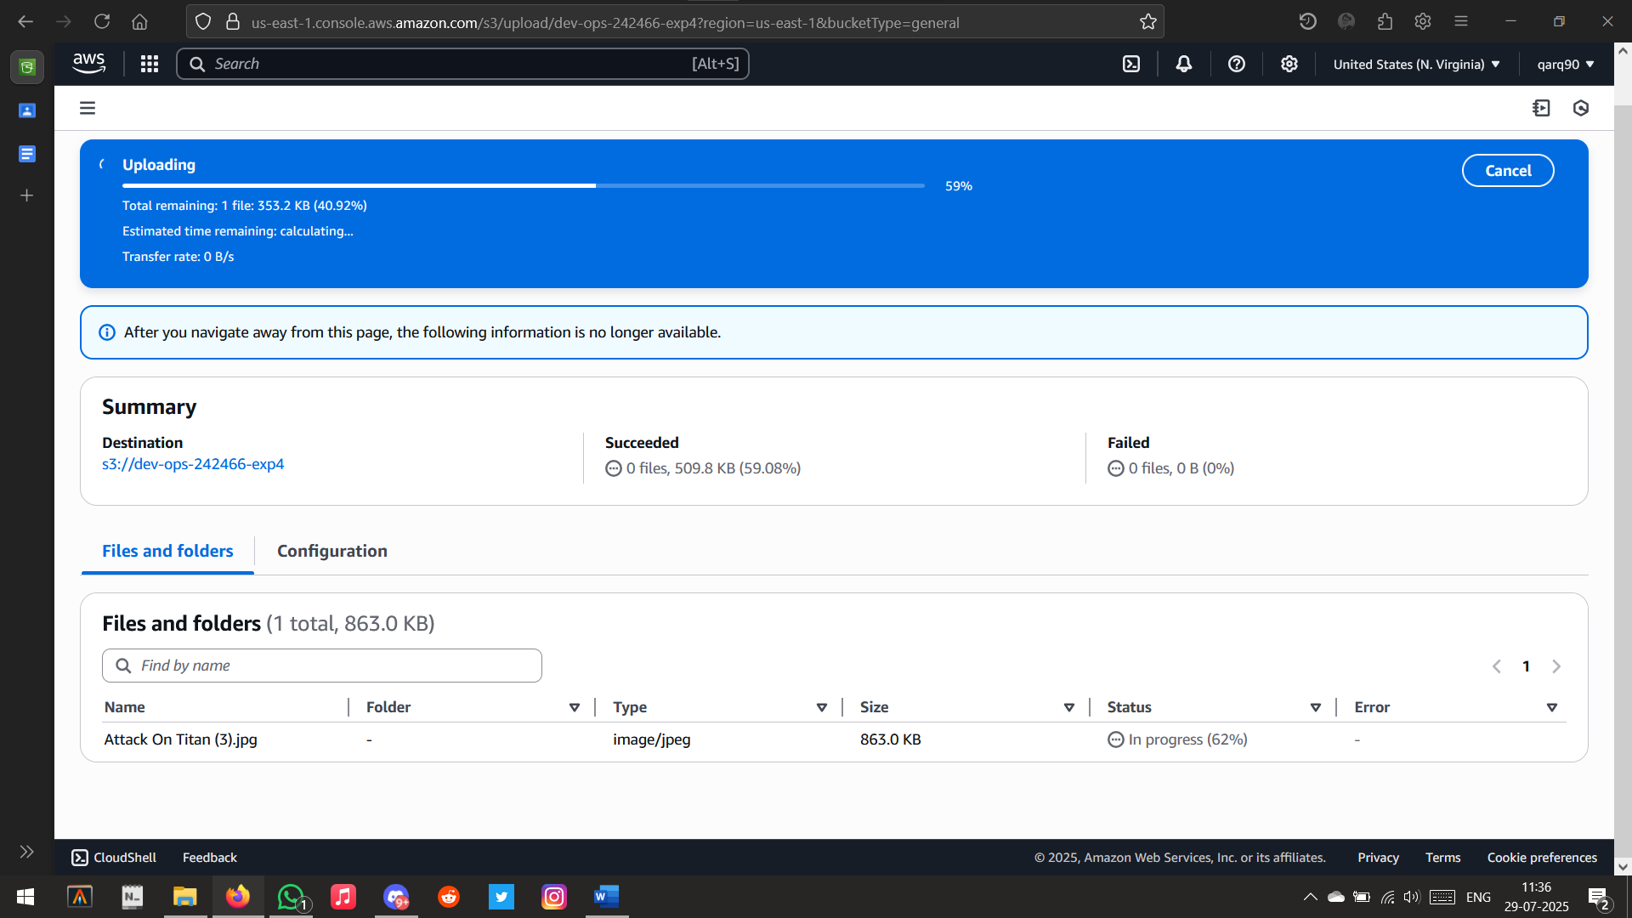

Uploading a file to the s3 bucket

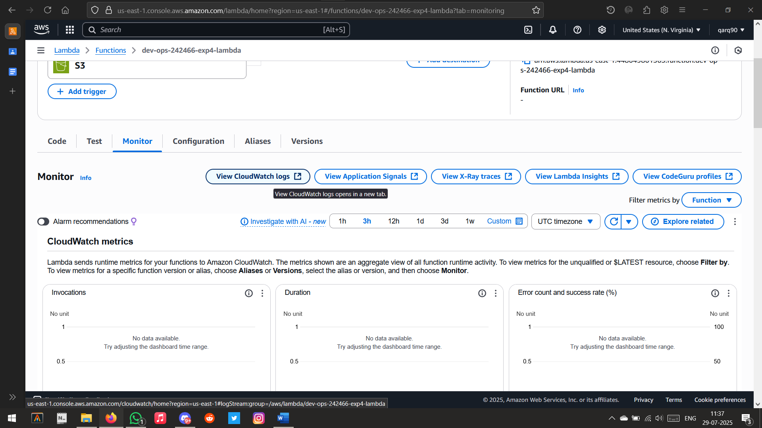

Opening

Logs

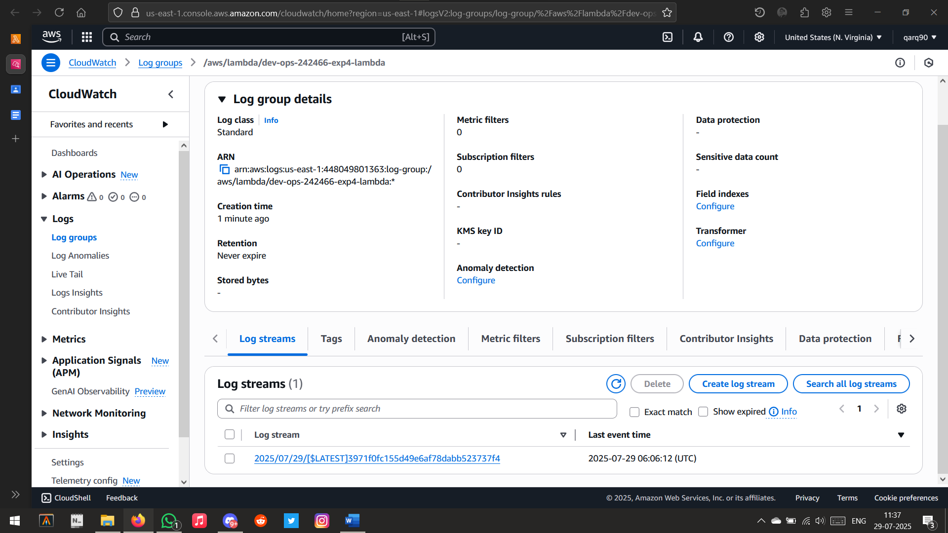Log Created

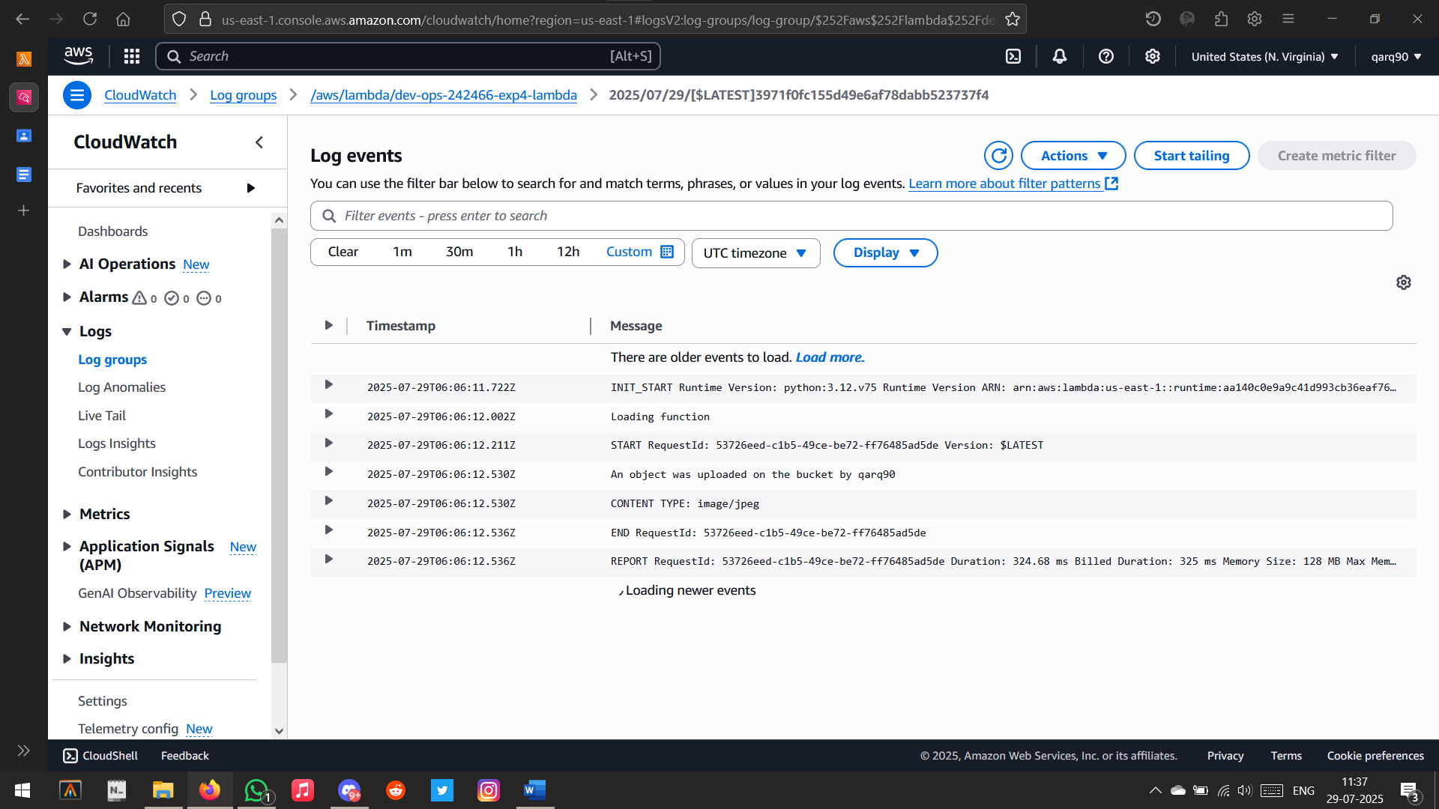

Log Result